REPORT
On the results of the survey of user satisfaction with statistical information provided by the Agency on Statistics under the President of the Republic of Tajikistan

Contractor: LLC “Ressel Bedford AAA”

Client: Agency on Statistics under the President of the Republic of Tajikistan

Dushanbe. 2026

Оглавление
CHAPTER 1: INTRODUCTION 4
1.1 General Provisions 4
1.2 Purpose of the Survey- 5
1.3 Sampling Procedure and Survey Coverage 6
1.3.1 Sampling 6
1.3.2 Sample Size 7
1.3.3 Tools and Software Used 7
CHAPTER II. USE OF DATA AND PUBLICATIONS OF THE AGENCY ON STATISTICS UNDER THE PRESIDENT OF THE REPUBLIC OF TAJIKISTAN 8
2.1 Characteristics of Respondents 8
2.2 Use of Statistical Data among Enterprises and Organizations 11
2.3 Dissemination of Statistical Metadata 16
2.4 Assessment of the Quality of Official Statistical Information of the Agency for Statistics under the President of the Republic of Tajikistan 19
2.5 Customer Satisfaction Index for 2025 26
2.6 Comparability of the survey results with the results of previous surveys (from 2022 to 2025) 29
Questionnaire 31

Tables used for data analysis
Table 1. Survey Results 7
Table 2. Percentage Distribution of Respondents by Education Level and Gender 9
Table 3. Areas of Use of Statistical Information by Users 10
Table 4. Use of Statistical Information by Users by Frequency 14
Table 5. Customer Satisfaction Index for 2025 27
Table 5. Customer Satisfaction Index for 2025 28

Figures used for data analysis
Figure 1. Percentage distribution of the purposes for which users use statistical information 11
Figure 2. Share of Users of Official Statistical Information Sources 13
Figure 3. Users’ access to the main official information of the Agency for Statistics 16
Figure 4. Users’ use of statistical data 19
Figure 5. Assessment of the sufficiency of official statistical information by statistical domains and user groups 22
Figure 6. Assessment of the activities of the Agency for Statistics 23
Figure 7. Distribution of users of statistical information by age groups 24
Figure 8. Satisfaction Index (2022–2025) 30

CHAPTER 1: INTRODUCTION
  - General Provisions
Within the framework of the project “Modernization of the National Statistical System in Tajikistan” for 2022–2026, financed by the World Bank, LLC “Russell Bedford” conducted a survey of user satisfaction with statistical information. During this survey, detailed responses to a wide range of questions were collected and analyzed. Data collection was carried out from February 25, 2026, to March 13, 2026, using an electronic questionnaire.
The survey was purposefully designed, and its main objective was to assess the extent to which statistical data meet the requirements and needs of users. In other words, the survey determined the degree to which the statistical information provided corresponds to the expectations and needs of different user groups.
The survey results serve as an important analytical tool for assessing the quality, accessibility, and reliability of official statistical information. At the same time, they make it possible to identify existing shortcomings and issues in the system of statistical data dissemination, as well as to determine areas requiring further improvement, development, and the introduction of modern methods for managing and disseminating statistical information. In addition, the results of the survey can serve as a solid basis for improving information policy, increasing the efficiency of statistical bodies, and enhancing user services.
  - Purpose of the Survey-
The main purpose of the survey of user satisfaction with statistical information is to determine the level of user satisfaction with the quality, accessibility, and timeliness of statistical data. The survey also aims to assess the reliability, completeness, and clarity of the information provided, and to determine the extent to which statistical data meet users’ requirements and needs.
In addition, the survey makes it possible to analyze the level of use of various sources of statistical information, including official websites, statistical publications, databases, and other dissemination channels. Thus, it helps identify which forms of data presentation are the most convenient and effective for users.
The survey also examines future user needs for statistical information, the most in-demand types of data, and ways to improve interaction between the Agency of Statistics and users of statistical information. The results of the survey can be used to develop strategies and follow-up measures aimed at improving the efficiency of statistical bodies and adapting services to the real needs of users.

1.3 Sampling Procedure and Survey Coverage

1.3.1 Sampling
The sampling procedure used in this survey covers a list of users of statistical information at the city and district levels. It should be noted that cities and districts of the Republic of Tajikistan differ in geographical conditions, traditions, and characteristics of socio-economic development. Taking these factors into account, and in order to identify user needs for statistical information, entities related to statistics at the national, regional, and district levels were included in the survey sample.
At the same time, this sampling approach makes it possible to comprehensively and objectively collect the opinions and needs of different groups of users of statistical information, thereby creating a basis for improving the system of statistical data dissemination and enhancing its quality.
Involving a wide range of users in the survey process makes it possible to accurately determine their needs and expectations regarding the accessibility, timeliness, reliability, and completeness of statistical information. The results of such a survey can be used to improve the activities of statistical bodies, enhance data presentation formats, and develop information services.
In addition, analysis of the data obtained makes it possible to identify key areas for improving interaction between the Agency of Statistics and users of statistical information, as well as to strengthen effective mechanisms for their dissemination and use in decision-making and the development of socio-economic policy.

1.3.2 Sample Size
In this survey, the total number of organizations and institutions covered amounted to 400 units (see Table 1). These organizations and institutions were selected across various sectors of economic and social activity to ensure broad coverage of the survey subjects. Covering such a number of organizations and institutions increases the reliability of the survey results and ensures that they more accurately reflect the real situation.
At the same time, it should be noted that responses were received from 380 of the surveyed entities, which составляет 95%.

Table 1. Survey Results
 | Public Sector | Private Sector | Total
 | Количество
Completed | 160 | 220 | 380
Partially completed | 0 | 0 | 0
Rejected | 10 | 10 | 20
Total | 170 | 230 | 400

1.3.3 Tools and Software Used
In order to ensure the accuracy, reliability, and efficiency of data collection, processing, and analysis within the framework of the survey of users of statistical information in the Republic of Tajikistan, a wide range of specialized tools and software solutions was employed. The use of modern technologies made it possible to implement all stages of the survey - from data collection through surveys to the processing and analysis of results- with a high level of efficiency.
At the same time, the introduction of these tools ensured flexibility in the data collection process and made it possible to take into account various regional characteristics and existing differences in access to digital technologies and technical equipment. This approach contributed to obtaining reliable results and an objective assessment of the level of use of and satisfaction with statistical information among users.

CHAPTER II. USE OF DATA AND PUBLICATIONS OF THE AGENCY ON STATISTICS UNDER THE PRESIDENT OF THE REPUBLIC OF TAJIKISTAN

2.1 Characteristics of Respondents
The survey results show that respondents differ by level of education. According to the data in Table 2, the majority of respondents have higher professional education, accounting for 70.5%.
At the same time, 15.8% of respondents have secondary professional education. The share of individuals with primary vocational education is relatively lower, at 7.6%. The proportion of respondents with general secondary education is 6.1%.
Overall, the data in the table indicate that most respondents have higher professional education, while the share of individuals with other levels of education is comparatively lower.
Table 2. Percentage Distribution of Respondents by Education Level and Gender
 | Men | Women | Total
General secondary education | 4,0 | 2,1 | 6,1
Primary vocational education | 5,5 | 2,1 | 7,6
Secondary vocational education | 10,8 | 5,0 | 15,8
Higher professional education | 52,4 | 18,2 | 70,5
Total | 72,6 | 27,4 | 100
The survey results show that respondents use information for various purposes. According to the data in Table 3, information is most frequently used for policy development and managerial decision-making - 116 cases, or 30.5%.
In addition, 82 cases (21.6%) indicate the use of information for preparing reports, presentations, and forecasts as part of official duties. Educational purposes account for 50 cases, or 13.2%.
Furthermore, 32 cases (8.4%) were recorded for the use of information in preparing publications or printed materials, 27 cases (7.1%) for professional, commercial activities or marketing research, and 26 cases (6.8%) for data analysis.
There were also 24 cases (6.3%) of information use for scientific research purposes and 23 cases (6.1%) for use in mass media.
Overall, 380 responses were recorded, indicating that respondents use information across various fields of professional, scientific, and managerial activities (see Table 3).
Table 3. Areas of Use of Statistical Information by Users
 | Number | Percentage
Policy development, managerial decision-making | 116 | 30,5
Professional activity / business / marketing research | 27 | 7,1
Preparation of reports, presentations, and forecasts for official duties | 82 | 21,6
Educational purposes | 50 | 13,2
Scientific research purposes | 24 | 6,3
Preparation of reports or publications | 32 | 8,4
Data analysis | 26 | 6,8
Use in mass media | 23 | 6,1
Policy development, managerial decision-making | 380 | 100

Figure 1. Percentage distribution of the purposes for which users use statistical information

2.2 Use of Statistical Data among Enterprises and Organizations
In this survey, in order to determine the level of use of official statistical data from the Agency for Statistics under the President of the Republic of Tajikistan among organizations and enterprises, it was found that the ways in which these data are used are diverse. It was also revealed that the level of use of official statistics varies across different groups.
According to the results presented in Table 4, approximately 71% of government bodies (both central and local authorities) indicated that they had used official statistics at least once. All international organizations and research institutions that participated in the survey also reported that they had used statistics produced by the Agency at least once.
Overall, the analysis shows that 67.3% of respondents had used official data from the Agency for Statistics under the President of the Republic of Tajikistan at least once per year. This indicates that official statistics are widely used as an information source at various levels of enterprises and organizations; however, the level and frequency of use vary depending on the type of organization and its objectives.
Statistics is one of the most important sources of information for the activities of organizations and institutions. In this regard, respondents were asked about the sources from which they most frequently obtain statistical information. The results show that the majority of respondents primarily obtain statistical data from the website of the Agency for Statistics (60%). This indicates that the official website is one of the most important channels for accessing statistical information.
The second most common source is the publications of the Agency for Statistics, which are used by 41% of respondents. At the same time, 39% of respondents obtain statistical information through mass media.
A relatively smaller share of respondents obtains statistical data from the websites of other government agencies (15%) and by contacting the Agency or its regional offices (11%). The smallest proportion of respondents uses statistical information from publications or websites of international organizations (3%).
Overall, the results show that official electronic sources - especially the website of the Agency for Statistics - play a key role in ensuring user access to statistical information (see Figure 2).
Figure 2. Share of Users of Official Statistical Information Sources

Table 4. Use of Statistical Information by Users by Frequency
 | Daily | Every quarter | Several times per quarter | Once per half-year | Once per year (Як маротиба дар як сол) | Once per year | Total
Political party or organization | 32 | 0 | 5 | 0 | 2 | 0 | 39
Non-governmental organization | 17 | 7 | 30 | 1 | 1 | 1 | 57
International organization | 0 | 0 | 0 | 3 | 0 | 1 | 4
Teacher or student | 0 | 4 | 7 | 5 | 38 | 14 | 68
Researcher | 0 | 0 | 3 | 1 | 0 | 23 | 27
Mass media | 15 | 15 | 14 | 1 | 0 | 1 | 46
Private enterprise | 7 | 0 | 1 | 1 | 6 | 11 | 26
Industry association | 0 | 0 | 6 | 9 | 1 | 0 | 16
Total | 0 | 10 | 45 | 10 | 0 | 21 | 86
Political party or organization | 0 | 0 | 9 | 2 | 0 | 0 | 11
Non-governmental organization | 71 | 36 | 120 | 33 | 48 | 72 | 380

Figure 3 shows that users generally assess access to information from the Agency for Statistics positively. According to the survey results, the majority of respondents consider access to statistical information to be easy. The share of such responses in most cases exceeds half of all answers and in some cases reaches more than 70 - 80%. This indicates that most users are able to obtain the necessary statistical information without difficulty.
At the same time, some users rated access as very easy, which is also a positive indicator of the performance of statistical authorities in providing information. However, in some cases, a certain group of respondents assessed access to information as difficult or very difficult. Although the share of such responses is relatively small, their presence indicates the potential for further improving the accessibility of statistical data and simplifying the ways in which it is used.
Overall, the results of the survey show that access to official information from the Agency for Statistics is convenient for the majority of users; at the same time, there remains a need to continue efforts to improve the mechanisms for providing statistical data.
Figure 3. Users’ access to the main official information of the Agency for Statistics

2.3 Dissemination of Statistical Metadata
Access to metadata is one of the key areas of activity of the Agency for Statistics under the President of the Republic of Tajikistan. In this context, the transparency and clarity of the statistical information environment are of great importance, namely the extent to which the information provided is accompanied by relevant documentation and metadata, as well as explanatory materials such as charts, tables, and maps.
At the same time, the provision of supporting information and additional explanations is important for users, as some of them may experience difficulties in understanding certain concepts and complex statistical methods used in the preparation and interpretation of data. Therefore, the availability of comprehensive metadata enables users to correctly understand statistical information and use it effectively.
In this regard, the Agency for Statistics under the President of the Republic of Tajikistan is making efforts to provide clear, accessible, and comprehensive metadata so that users can correctly interpret statistical data and effectively apply it in their activities.
Based on the presented results (Figure 3), respondents were asked to assess the ease of access to metadata for each official statistical domain they used.
The results show that the highest level of ease of access to metadata was reported for environmental statistics, with 65% of respondents rating access as easy or very easy. This is followed by national statistics, tourism, as well as population census results and some administrative data, for which around 63% of respondents reported easy access. A relatively high level of accessibility is also observed for production and energy supply statistics (61%), crime and judicial statistics (60%), agriculture (58%), and investment and construction (57%).
On the other hand, some areas show a comparatively lower level of ease of access to metadata. The lowest figure was recorded for demographic statistics, where only 36% of respondents rated access as easy. This is followed by regional statistics (43%), trade and services (45%), and labor market and employment statistics (45%).
Overall, the results indicate that although access to metadata is considered relatively convenient for most areas of official statistics, there is still a need to improve accessibility and provide more user-friendly presentation of metadata in certain domains (see Figure 4).
Figure 4. Users’ use of statistical data

2.4 Assessment of the Quality of Official Statistical Information of the Agency for Statistics under the President of the Republic of Tajikistan
The Agency for Statistics under the President of the Republic of Tajikistan places particular importance on providing users with high-quality, reliable, and useful information. One of the Agency’s main tasks is to meet users’ needs through the production and dissemination of accurate and accessible official statistics.
Data quality is determined by accuracy, timeliness, relevance, accessibility, and reliability. The Agency applies a systematic mechanism for controlling and assessing data quality at the stages of data collection, editing, verification, processing, and analysis in order to maintain high standards. This process makes it possible to identify shortcomings and issues in a timely manner, take corrective and improvement measures, and ensure the transparency and reliability of statistical information.
The level of user satisfaction with the accuracy, accessibility, timeliness, and usefulness of statistical information is also assessed. The results of this assessment define priority areas for improving statistical activities and enhancing the quality of statistical services, thereby strengthening public and user trust in official statistics.
Based on the results of the survey of users of statistical data, the level of sufficiency of statistical information in most areas of official statistics was assessed positively by different user groups. Previously, respondents also evaluated aspects of statistical quality, with data timeliness being assessed as sufficient by 89.2% and insufficient by 10.2% (see Figure 5).
The results of the assessment also show that most users consider the volume and coverage of statistical information in various areas to be sufficient. For example, in areas such as living standards and poverty, gender statistics, crime and judicial statistics, business statistics, prices, population census results, and agricultural census results, the information provided is generally considered adequate. This indicates that in these fields, the provision of statistical information fully meets user requirements.
At the same time, in some areas the level of user satisfaction is relatively lower. For example, in labor market and employment statistics, trade and services, and in some cases financial statistics, a higher proportion of users assessed the information as insufficient. In particular, in the labor market area, some user groups such as central government bodies, teachers, and students rated the sufficiency of information lower.
Overall, the survey results indicate that most areas of official statistics are sufficiently covered in terms of user needs. Nevertheless, in some domains there remains a need to improve data coverage and accessibility, as well as to better adapt statistical products to the requirements of different user groups.

Figure 5. Assessment of the sufficiency of official statistical information by statistical domains and user groups

Figure 6 shows the results of the assessment of the activities of the Agency for Statistics for 2025. According to the data obtained, the majority of survey participants positively evaluated the Agency’s performance. In particular, 63.5% of respondents stated that they are satisfied with the Agency’s work and rated it as very good. This indicator shows that most users consider the Agency’s work to be effective and in line with requirements.
Figure 6. Assessment of the activities of the Agency for Statistics
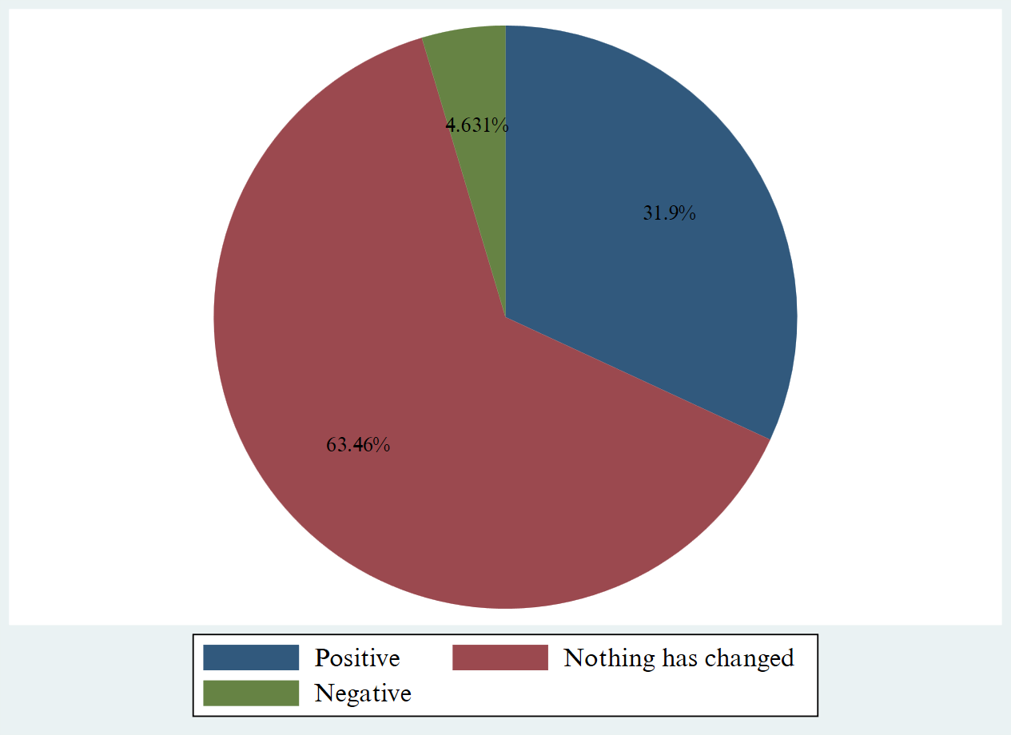

At the same time, 31.9% of survey participants positively evaluated the Agency’s activities. This group considers the institution’s work to be satisfactory and believes that it generally meets the needs of users of statistical information.
Meanwhile, only 4.6% of respondents rated the Agency’s performance negatively. The low level of this indicator shows that the number of dissatisfied respondents is relatively small, while the majority of participants are satisfied with the Agency’s work.
Overall, the results of the analysis indicate that the activities of the Agency for Statistics in 2025 were mainly assessed positively by society, with a high level of trust and user satisfaction with statistical information.
Figure 7 presents the distribution of users of statistical data by age group. The data analysis shows that the largest share of users belongs to the 36–50 age group, accounting for 40% of the total number of participants. This indicates that the greatest interest in using such data or related services is shown by people of middle age.
Figure 7. Distribution of users of statistical information by age groups
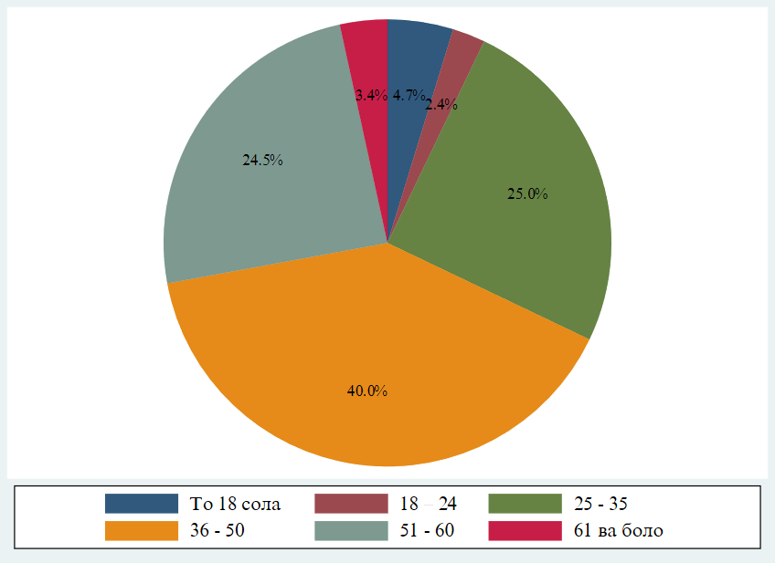

The second largest group is the 25–35 age group, which accounts for 25% of users. This group also represents a significant share, indicating a relatively high level of activity in the use of statistical data.
At the same time, the 51–60 age group, with 24.5%, is close to the previous group. This shows that people of relatively older age also demonstrate considerable interest in using statistical data.
Compared to these groups, the shares of other age categories are relatively small. In particular, the under-18 group accounts for 4.7%, the 61 and older group for 3.4%, and the 18–24 group for only 2.4% of users. This indicates that the participation of very young people as well as elderly individuals in the use of statistical data is relatively limited.

2.5 Customer Satisfaction Index for 2025
One of the outputs expected of the survey was to calculate an overall user satisfaction index which would allow for comparison with previous survey results. In computing a Customer Satisfaction Index, it was necessary firstly to establish the relative importance that users attach to the five parameters as shown in question 9. The respondents were asked to rank the five parametr in order of the relative weight which they give to each of them, giving 1 for the parameter which is least important and 5 for the most important to them. The number of respondents rating each of the five parameters was computed and the scores were aggregated (Table 5). An average score was then calculated for each quality parameter. This average score represents the weighting that users attach to that quality parameter relative to the other four quality criteria.
According to the results presented in Table 6, the Customer Satisfaction Index reached 4.1 in this survey, indicating a generally high level of user satisfaction. This result suggests that, overall, respondents positively evaluated the quality and relevance of the statistical information provided. The Customer Satisfaction Index value reflects a strong performance across the assessed parameters, with users expressing a relatively high degree of confidence and satisfaction compared to previous measurements.

Table 5. Customer Satisfaction Index for 2025
 | No. of respondents rating each parameter |  |  |  |  | Aggregated score | No of respondents | Weighting
 | 1 | 2 | 3 | 4 | 5 | Aggregated score | No of respondents | Weighting
1. National accounts | 0 | 2 | 3 | 4 | 5 | 54 | 14 | 3,9
2. Finance | 0 | 0 | 18 | 140 | 20 | 714 | 178 | 4,0
3. Labor market and employment | 0 | 2 | 36 | 308 | 10 | 1394 | 356 | 3,9
4. Living standards and poverty | 0 | 0 | 42 | 640 | 30 | 2836 | 712 | 4,0
5. Gender statistics | 0 | 0 | 24 | 88 | 5 | 449 | 117 | 3,8
6. Demography | 0 | 0 | 18 | 84 | 0 | 390 | 102 | 3,8
7. Education and science | 0 | 0 | 30 | 268 | 5 | 1187 | 303 | 3,9
8. Healthcare | 0 | 0 | 48 | 128 | 10 | 706 | 186 | 3,8
9. Crime and judicial statistics | 0 | 0 | 27 | 76 | 0 | 385 | 103 | 3,7
10. Agriculture | 0 | 0 | 0 | 24 | 0 | 96 | 24 | 4,0
11. Environmental protection | 0 | 4 | 18 | 108 | 5 | 519 | 135 | 3,8
12. Business statistics (e.g., enterprises and entrepreneurs) | 0 | 0 | 21 | 44 | 5 | 264 | 70 | 3,8
13. Prices | 0 | 0 | 6 | 56 | 10 | 292 | 72 | 4,1
14. Trade and services | 0 | 0 | 15 | 68 | 10 | 367 | 93 | 3,9
15. Tourism | 0 | 0 | 54 | 310 | 20 | 1502 | 384 | 3,9
16. Transport and communications | 0 | 0 | 27 | 40 | 10 | 291 | 77 | 3,8
17. Industry | 0 | 8 | 27 | 48 | 20 | 389 | 103 | 3,8
18. Construction and investment | 0 | 0 | 33 | 152 | 5 | 732 | 190 | 3,9
19. Electricity production (supply) and water supply | 0 | 0 | 9 | 84 | 5 | 388 | 98 | 4,0
20. Sustainable Development Goals (SDG) indicators | 0 | 0 | 0 | 24 | 35 | 271 | 59 | 4,6
21. Population census results | 0 | 0 | 6 | 28 | 0 | 130 | 34 | 3,8
22. Agricultural census results | 0 | 0 | 9 | 20 | 20 | 207 | 49 | 4,2
23. Regional statisti | 0 | 0 | 0 | 8 | 5 | 57 | 13 | 4,4
24. Other | 0 | 0 | 6 | 12 | 0 | 66 | 18 | 3,7
Table 6. Customer Satisfaction Index for 2025
 | Weighting | Score | Weighting (Average) | Weighting
1. National accounts | 3,9 | 3,86 | 0,20 | 4,06
2. Finance | 4,0 | 4,01 | 0,21 | 4,22
3. Labor market and employment | 3,9 | 3,92 | 0,21 | 4,12
4. Living standards and poverty | 4,0 | 3,98 | 0,21 | 4,19
5. Gender statistics | 3,8 | 3,84 | 0,20 | 4,04
6. Demography | 3,8 | 3,82 | 0,20 | 4,03
7. Education and science | 3,9 | 3,92 | 0,21 | 4,12
8. Healthcare | 3,8 | 3,80 | 0,20 | 4,00
9. Crime and judicial statistics | 3,7 | 3,74 | 0,20 | 3,94
10. Agriculture | 4,0 | 4,00 | 0,21 | 4,21
11. Environmental protection | 3,8 | 3,84 | 0,20 | 4,05
12. Business statistics (e.g., enterprises and entrepreneurs) | 3,8 | 3,77 | 0,20 | 3,97
13. Prices | 4,1 | 4,06 | 0,21 | 4,27
14. Trade and services | 3,9 | 3,95 | 0,21 | 4,16
15. Tourism | 3,9 | 3,91 | 0,21 | 4,12
16. Transport and communications | 3,8 | 3,78 | 0,20 | 3,98
17. Industry | 3,8 | 3,78 | 0,20 | 3,98
18. Construction and investment | 3,9 | 3,85 | 0,20 | 4,06
19. Electricity production (supply) and water supply | 4,0 | 3,96 | 0,21 | 4,17
20. Sustainable Development Goals (SDG) indicators | 4,6 | 4,59 | 0,24 | 4,84
21. Population census results | 3,8 | 3,82 | 0,20 | 4,03
22. Agricultural census results | 4,2 | 4,22 | 0,22 | 4,45
23. Regional statisti | 4,4 | 4,38 | 0,23 | 4,62
24. other | 3,7 | 3,67 | 0,19 | 3,86
Customer Satisfaction Index |  |  |  | Aver = 4,1

2.6 Comparability of the survey results with the results of previous surveys (from 2022 to 2025)
The satisfaction index over time demonstrates a consistent and meaningful upward trajectory across the four survey periods. In 2022, the index stood at 3.4, indicating a moderate level of user satisfaction with clear room for improvement. At this stage, user experiences were likely uneven, with a mix of positive and negative feedback influencing the overall score.
In 2023, the index had risen to 3.9, marking a substantial improvement. This increase suggests that changes implemented after the initial survey—such as enhancements in usability, performance, or customer support—had a strong positive impact. The shift above the 4.0 threshold is particularly important, as it typically reflects a transition from average satisfaction to a more favorable and competitive user perception.
In 2025, the satisfaction index reached 4.1, continuing the upward trend but at a slower rate of growth. This pattern indicates that while improvements are still being made, the system is approaching a level of maturity where large gains are harder to achieve. Incremental refinements, rather than major changes, are now driving satisfaction.
Overall, the progression from 3.4 to 4.1 (Figure 8) reflects sustained improvement, effective response to user feedback, and increasing alignment between user expectations and the delivered experience.

Figure 8. Satisfaction Index (2022–2025)

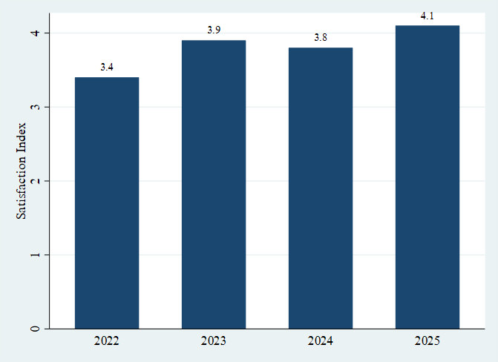

Dear users!
Russell Bedford AAA LLC conducts a survey to survey the opinions of users of official statistical information provided by the Agency on Statistics under the President of the Republic of Tajikistan and its territorial bodies (hereinafter referred to as the Agency).
Please take part in the survey. Your personal information will not be disclosed, and your answers will play a key role in strengthening official statistics in Tajikistan within the framework of the project "Modernization of the National Statistical System in Tajikistan". In this regard, you will be provided with a questionnaire to present your views and opinions.
We will be grateful if you spend a little time and fill out the questionnaire.

Questionnaire
I. Use of official statistical information
1. Do you use the official statistical information provided by the Agency?
Yes No (go to question #19)
2. How often do you use the official statistical information provided by the Agency?
1 | daily
2 | every week
3 | 2-3 times a month
4 | every quarter
5 | several times a quarter
6 | once every six months
7 | once a year
8 | Less frequently

3. For what purpose do you use official statistical information? (there are several possible answers)
1 | policy development, management decision-making
2 | professional activity/business/marketing research
3 | generation of reports, reports, forecasts for the performance of official duties
4 | for educational purposes
5 | research objectives
6 | for the preparation of reports or publications
7 | data analytics
8 | for use in the media
9 | other purpose (please decipher)
4. What official statistical information do you use? (there are several possible answers)
1 | National accounts
2 | Finance
3 | Labor market and employment of the population
4 | Living standards and poverty
5 | Gender statistics
6 | Demography
7 | Education and science
8 | Health care
9 | Offences and judicial statistics
10 | Agriculture
11 | Environmental protection
12 | Business statistics (e.g. businesses and entrepreneurs)
13 | Prices
14 | Trade and services
15 | Tourism
16 | Transport and communications
17 | Industry
18 | Construction and investment
19 | Production (provision) of electricity, water supply
20 | Data on Indicators of the Sustainable Development Goals
21 | Results of population censuses
22 | Results of agricultural censuses
23 | Regional statistics
24 | Other (specify)

5. What other data topics or indicators would you like to see in official statistics?

Please specify ______________________________________________________________
______________________________________________________________________
________________________________________________________________

6. What sources of official statistical information do you use? (there are several possible answers)
1 | official press releases / website of the Agency for Statistics
2 | publications of the Agency on Statistics (paper versions - collections, bulletins)
3 | appeals to the Agency / its territorial bodies (in writing on paper, in the format of an electronic document, by phone, personal reception)
4 | official press releases / website of another government agency
5 | Mass media
6 | publications/websites of international organizations such as: International Monetary Fund (IMF), United Nations (UN), World Bank (WB)
7 | others (specify which sources)________________________
 | ____________________________________________
 | ____________________________________________

7. In what form do you receive materials/data from the Agency on Statistics most often?
1 | in electronic form (Download for free from the site, receive by mailing, etc.)
2 | in paper form (On official request, handouts at conferences, etc.)
3 | mixed method (both electronic and paper)

8. How accessible are the official statistics for you?
(1 = difficult; 2 = quite difficult; 3 = quite easy; 4 = easy)
N | Direction | Evaluation
N | Direction | 1 | 2 | 3 | 4
1 | National accounts
2 | Finance
3 | Labor market and employment of the population
4 | Living standards and poverty
5 | Gender statistics
6 | Demography
7 | Education and science
8 | Health care
9 | Offences and judicial statistics
10 | Agriculture
11 | Environmental protection
12 | Business statistics (e.g. enterprises and entrepreneurs)
13 | Prices
14 | Trade and services
15 | Tourism
16 | Transport and communications
17 | Industry
18 | Construction and investment
19 | Production (provision) of electricity, water supply
20 | Data on Indicators of the Sustainable Development Goals
21 | Results of population censuses
22 | Results of agricultural censuses
23 | Regional statistics
24 | Other (specify)

8.1 If you think that the Agency should take measures to improve the quality of availability of statistical data, please indicate which ones?
- ____________________________________________________________
- ____________________________________________________________

9. Please rate the level of satisfaction with official statistical information in the context of the areas of greatest interest to you (select a score on a 5-point scale, where 1 is completely dissatisfied, 5 is completely satisfied)
N | Direction | Evaluation
N | Direction | 1 | 2 | 3 | 4 | 5
1 | National accounts
2 | Finance
3 | Labor market and employment of the population
4 | Living standards and poverty
5 | Gender statistics
6 | Demography
7 | Education and science
8 | Health care
9 | Offences and judicial statistics
10 | Agriculture
11 | Environmental protection
12 | Business statistics (e.g. enterprises and entrepreneurs)
13 | Prices
14 | Trade and services
15 | Tourism
16 | Transport and communications
17 | Industry
18 | Construction and investment
19 | Production (provision) of electricity, water supply
20 | Data on Indicators of the Sustainable Development Goals
21 | Results of population censuses
22 | Results of agricultural censuses
23 | Regional statistics
24 | Other (specify)

II. Activities of the Agency in providing official statistical information
10. Please rate the official statistical information provided by the Agency on a 5-point scale, where 1 is completely dissatisfied, 5 is completely satisfied, according to the following criteria:
Criterion | Evaluation
Criterion | 1 | 2 | 3 | 4 | 5
Level of detail of information
Presentation format (doc, excel)
Efficiency
Correctness
Topicality
Meeting your requirements
Frequency of provision
Consistency of information
Accessing metadata
Easy to read
Comments and analysis
Graphical representation of data
Ease of further use

10.1 If you think that the Agency should take measures to improve the official statistical information provided, please indicate which ones?
- ____________________________________________________________
- ____________________________________________________________

11. How clear are the methodological clarifications to the statistical data of the Agency for you?
Completely understandable
Rather understandable
Rather incomprehensible
Incomprehensible

12. How do you assess the available amount of statistical information in the context of the directions published by the Agency?

N | Direction | Enough | Insufficiently
1 | National accounts
2 | Finance
3 | Labor market and employment of the population
4 | Living standards and poverty
5 | Gender statistics
6 | Demography
7 | Education and science
8 | Health care
9 | Offences and judicial statistics
10 | Agriculture
11 | Environmental protection
12 | Business statistics (e.g. enterprises and entrepreneurs)
13 | Prices
14 | Trade and services
15 | Tourism
16 | Transport and communications
17 | Industry
18 | Construction and investment
19 | Production (provision) of electricity, water supply
20 | Data on Indicators of the Sustainable Development Goals
21 | Results of population censuses
22 | Results of agricultural censuses
23 | Regional statistics
24 | Other (specify)

13. How much do you trust the official statistics?
N | Direction | I fully trust | Rather, I trust | I rather don't trust | I don't trust
1 | National accounts
2 | Finance
3 | Labor market and employment of the population
4 | Living standards and poverty
5 | Gender statistics
6 | Demography
7 | Education and science
8 | Health care
9 | Offences and judicial statistics
10 | Agriculture
11 | Environmental protection
12 | Business statistics (e.g. enterprises and entrepreneurs)
13 | Prices
14 | Trade and services
15 | Tourism
16 | Transport and communications
17 | Industry
18 | Construction and investment
19 | Production (provision) of electricity, water supply
20 | Data on Indicators of the Sustainable Development Goals
21 | Results of population censuses
22 | Results of agricultural censuses
23 | Regional statistics
24 | Other (specify)

14. What types of materials containing official statistical information do you prefer to use? (there are several possible answers)
statistical tables
analytical reviews
statistical compilations
time series
Graphs/Charts
requests for official statistical information
materials in the media
other kind (decipher please)

15. What reasons do you think are detrimental to the quality of the Agency's statistics?
N | Direction | Lack of impressions | Dignity of the showers | Methodological clarification | Presentation period | Presentation form
1 | National accounts
2 | Finance
3 | Labor market and employment of the population
4 | Living standards and poverty
5 | Gender statistics
6 | Demography
7 | Education and science
8 | Health care
9 | Offences and judicial statistics
10 | Agriculture
11 | Environmental protection
12 | Business statistics (e.g. enterprises and entrepreneurs)
13 | Prices
14 | Trade and services
15 | Tourism
16 | Transport and communications
17 | Industry
18 | Construction and investment
19 | Production (provision) of electricity, water supply
20 | Data on Indicators of the Sustainable Development Goals
21 | Results of population censuses
22 | Results of agricultural censuses
23 | Regional statistics
24 | Other (specify)

16. Do you visit the official Internet portal of the Agency (www. stat. tj)?
(a) Yes (turn to question No. 17)
b) No (go to question No. 18)
17. How would you rate the official Internet portal of the Agency according to the following criteria: (Evaluate on a 5-point scale, where 1 - completely dissatisfied, and 5 - completely satisfied);
Criterion | Evaluation
 | 1 | 2 | 3 | 4 | 5
Completeness of information provision
Timeliness of updating information
Convenience
Interface
Easy to find information
Your overall impression

18. How do you assess the Agency's activities over the past year (2022) in general?
Above expectations
Positively
Nothing has changed
Negatively

CHARACTERISTICS OF DATA USERS
Please indicate your age:
1 | up to 18 years
2 | 18 – 24
3 | 25 - 35
4 | 36 - 50
5 | 51 - 60
6 | 61 and older

Please indicate your gender:
1 | male
2 | female

Please indicate the highest level of education achieved:
1 | primary education
2 | secondary education
3 | initial vocational education
4 | secondary vocational education
5 | higher professional education
6 | Ph.D. degree
7 | Ph.D.
8 | Other (please specify)

Please indicate your field of activity:
1 | Central authorities
2 | Local government
3 | Political party or organization
4 | Non-governmental organization
5 | International organization
6 | Teacher or student
7 | Researcher
8 | Media
9 | Private enterprise
10 | Private user
11 | Industry Association
12 | Other (please specify) __

19. Why don't you use statistical information?
1 | I didn't need statistical information
2 | Did not have access to the data that was needed
3 | Other (please specify) __

Thank you for participating in the survey!

